A Level Sociology

Transition Task 2022

The following tasks are designed to give you a good foundation and introduction to A level Sociology. These tasks will provide a helpful starting point for you whether you have studied Sociology at GCSE or not.

Research the tasks independently and complete the tasks in any format you choose and bring them to your first Sociology A level lesson.

It is important that you complete these tasks to a high standard and, most of all, try to enjoy the work and the research!



Name:

- Functionalism

1.1: Research Functionalism and produce a simple overview / factsheet which outlines the approach and the ‘organic analogy’ as a way to explain the main views and ideas of this Sociological perspective.

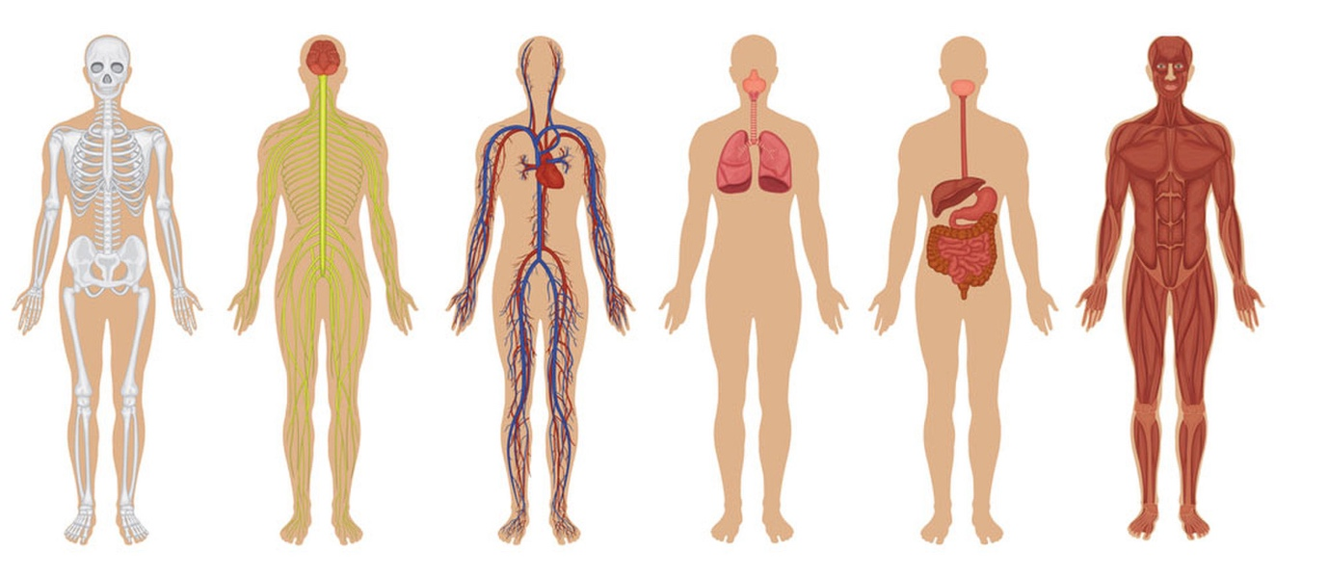

1.2: Watch the following clip from ‘The Adjustment Bureau’ and link it to the main ideas of Functionalism: https://www.youtube.com/watch?v=wZJ0TP4nTaE

1.3: In the box below, summarise everything you have learned or discovered about Functionalism

- Feminism

2.1: Watch the following clip ‘What’s Feminist about Equality’? and summarise below what it tells you about Feminism. You can use bullet points to summarise your main thoughts / points.

2.2: Research the book ‘The Second Sex’ by Simone DeBevoir and explain (below) why this was such an important piece of work for the Feminist movement.

- Marxism

3.1: Research and summarise the main ideas or views of Marxism as a Sociological perspective and summarise these below (this will be tricky as there are lots of ideas so aim to keep them simple and as a summary).

3.2: What are the differences between the Bourgeoisie and the Proletariat?

3.3: Watch the following clip and explain a) what Karl Marx meant by the term ‘alienation’ and what causes this to happen and b) what is the solution according to Karl Marx? https://www.youtube.com/watch?v=PZ4VzhIuKCQ

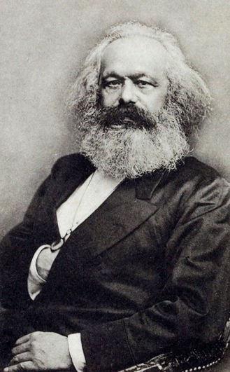

- Social Action Theories
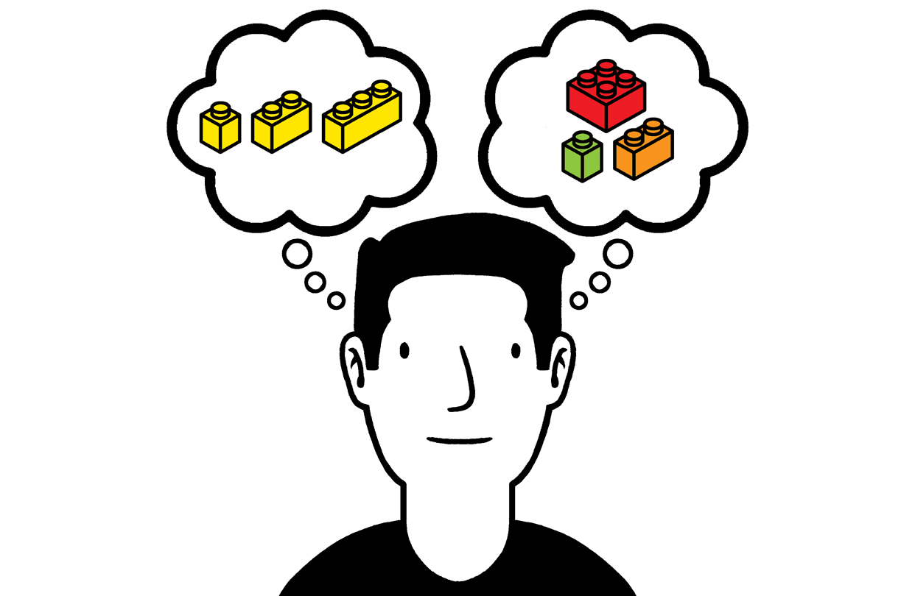
4.1: Define the following terms in the space below:
- Social Action Theories
- Labelling Theories
- Consensus and Conflict Theories

4.2: . Research Jane Elliot’s ‘Brown Eyes, Blue Eyes’ and ‘Angry eye’ experiments.

What would Social Action Theory say about these experiments and participants?

